**Step 1: Configure Laravel 5.6 Project.**

Install the brand new Laravel Project by the typing following command.

composer create-project --prefer-dist laravel/laravel passportappointmentsystem

**Step 2: Setup a MySQL database in .env file.**

Now, configure the database in the**.env**file.

DB_CONNECTION=mysql

DB_HOST=127.0.0.1

DB_PORT=3306

DB_DATABASE=passportsystem

DB_USERNAME=root

DB_PASSWORD=

I have set up local database credentials.

Next, migrate two tables provided by Laravel 5.6 Switch to your terminal and hit the following command.

php artisan migrate

It will build two tables in your database.

1. **users**
2. **password_resets**

**Step 3: Construct a model, migration file and controller for our Passports table.**

Type the following command in your terminal.

php artisan make:model Passport -m

It will create two files.

RELATED POSTS

[Laravel 5.8 Form Validation Tutorial With Example](https://appdividend.com/2019/03/09/laravel-5-8-form-validation-tutorial-with-example/)

Mar 9, 2019

[Laravel 5.8 CRUD Tutorial With Example For Beginners](https://appdividend.com/2019/03/08/laravel-5-8-crud-tutorial-with-example-for-beginners/)

Mar 8, 2019

 PREV NEXT  1 of 42

1. **Passport.php** model.
2. **create_passports_table** migration file.

We need to create Schema for the passports table. So navigate to **Laravel  >>  database  >>  migrations  >>  create_passports_table.**

*// create_passports_table*

public function up()

{

Schema::create('passports', function (Blueprint $table) {

$table->increments('id');

$table->string('name');

$table->integer('date');

$table->string('email')->unique();

$table->integer('number');

$table->string('office');

$table->string('filename');

$table->timestamps();

});

}

Now, migrate the table by the following command.

php artisan migrate

In the database, you can see the**passports**table.

**Step 4: Build view file to add the Information in the database.**

Create a file in the **resources  >>  views  >>   create.blade.php**and put the following code in it.

*<!-- create.blade.php -->*

<!DOCTYPE html>

<html>

<head>

<meta charset="utf-8">

<title>Laravel 5.6 CRUD Tutorial With Example </title>

<link rel="stylesheet" href="{{asset('css/app.css')}}">

<link href="https://maxcdn.bootstrapcdn.com/bootstrap/3.3.6/css/bootstrap.min.css" rel="stylesheet">

<link href="https://cdnjs.cloudflare.com/ajax/libs/bootstrap-datepicker/1.5.0/css/bootstrap-datepicker.css" rel="stylesheet">

<script data-src="http://ajax.googleapis.com/ajax/libs/jquery/1.9.1/jquery.js"></script>

<script src="https://maxcdn.bootstrapcdn.com/bootstrap/3.3.6/js/bootstrap.min.js"></script>

<script src="https://cdnjs.cloudflare.com/ajax/libs/bootstrap-datepicker/1.5.0/js/bootstrap-datepicker.js"></script>

</head>

<body>

<div class="container">

<h2>Passport Appointment System</h2><br/>

<form method="post" action="{{url('passports')}}" enctype="multipart/form-data">

@csrf

<div class="row">

<div class="col-md-4"></div>

<div class="form-group col-md-4">

<label for="Name">Name:</label>

<input type="text" class="form-control" name="name">

</div>

</div>

<div class="row">

<div class="col-md-4"></div>

<div class="form-group col-md-4">

<label for="Email">Email:</label>

<input type="text" class="form-control" name="email">

</div>

</div>

<div class="row">

<div class="col-md-4"></div>

<div class="form-group col-md-4">

<label for="Number">Phone Number:</label>

<input type="text" class="form-control" name="number">

</div>

</div>

<div class="row">

<div class="col-md-4"></div>

<div class="form-group col-md-4">

<input type="file" name="filename">

</div>

</div>

<div class="row">

<div class="col-md-4"></div>

<div class="form-group col-md-4">

<strong>Date : </strong>

<input class="date form-control" type="text" id="datepicker" name="date">

</div>

</div>

<div class="row">

<div class="col-md-4"></div>

<div class="form-group col-md-4">

<lable>Passport Office</lable>

<select name="office">

<option value="Mumbai">Mumbai</option>

<option value="Chennai">Chennai</option>

<option value="Delhi">Delhi</option>

<option value="Bangalore">Bangalore</option>

</select>

</div>

</div>

<div class="row">

<div class="col-md-4"></div>

<div class="form-group col-md-4" style="margin-top:60px">

<button type="submit" class="btn btn-success">Submit</button>

</div>

</div>

</form>

</div>

<script type="text/javascript">

$('#datepicker').datepicker({

autoclose: true,

format: 'dd-mm-yyyy'

});

</script>

</body>

</html>

[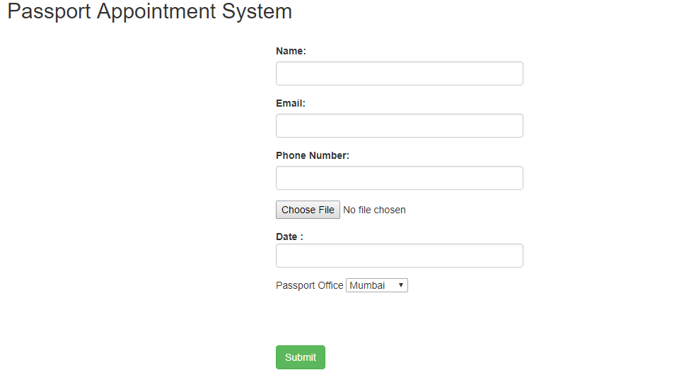](https://appdividend.com/wp-content/uploads/2018/02/Laravel-5.6-CRUD-Operations.png)

**Step 5: Create one controller and route**

php artisan make:controller PassportController *--resource*

It will create one controller file called

**PassportController.php**and It has all the CRUD Functions, we need to inquire.

we register one route in **routes  >>  web.php**file. So let us do it.

*// web.php*

Route::resource('passports','PassportController');

Now, turn to your terminal and type the next command.

php artisan route:list

Next step would be to go to **PassportController.php**file and add into **create()**function some code.

*// PassportController.php*

*/\*\**

*\* Show the form for creating a new resource.*

*\**

*\* @return \Illuminate\Http\Response*

*\*/*

public function create()

{

return view('create');

}

After that, we need to begin Laravel Development server. So in the terminal, follow the following command.

php artisan serve

Move to the browser and hit this URL: <http://localhost:8000/passports/create>

**Step 6: Save Data into Database.**

We require coding the store function in sequence to store the data in the database.

*//PassportController.php*

*/\*\**

*\* Store a newly created resource in storage.*

*\**

*\* @param \Illuminate\Http\Request $request*

*\* @return \Illuminate\Http\Response*

*\*/*

public function store(Request $request)

{

if($request->hasfile('filename'))

{

$file = $request->file('filename');

$name=time().$file->getClientOriginalName();

$file->move(public_path().'/images/', $name);

}

$passport= new \App\Passport;

$passport->name=$request->get('name');

$passport->email=$request->get('email');

$passport->number=$request->get('number');

$date=date_create($request->get('date'));

$format = date_format($date,"Y-m-d");

$passport->date = strtotime($format);

$passport->office=$request->get('office');

$passport->filename=$name;

$passport->save();

return redirect('passports')->with('success', 'Information has been added');

}

**Step 7: Make an index page to list the Information.**

For that, front, we need to forward the data to the **index.blade.php.**So, in **PassportController.php**file, we need to write the code to retrieve the data and return it to the **index view.**

*//PassportController.php*

public function index()

{

$passports=\App\Passport::all();

return view('index',compact('passports'));

}

In **resources** >> **views** produce individual blade file called **index.blade.php file**and placed the subsequent code in it.

*<!-- index.blade.php -->*

<!DOCTYPE html>

<html>

<head>

<meta charset="utf-8">

<title>Index Page</title>

<link rel="stylesheet" href="{{asset('css/app.css')}}">

</head>

<body>

<div class="container">

<br />

@if (\Session::has('success'))

<div class="alert alert-success">

<p>{{ \Session::get('success') }}</p>

</div><br />

@endif

<table class="table table-striped">

<thead>

<tr>

<th>ID</th>

<th>Name</th>

<th>Date</th>

<th>Email</th>

<th>Phone Number</th>

<th>Passport Office</th>

<th colspan="2">Action</th>

</tr>

</thead>

<tbody>

@foreach($passports as $passport)

@php

$date=date('Y-m-d', $passport['date']);

@endphp

<tr>

<td>{{$passport['id']}}</td>

<td>{{$passport['name']}}</td>

<td>{{$date}}</td>

<td>{{$passport['email']}}</td>

<td>{{$passport['number']}}</td>

<td>{{$passport['office']}}</td>

<td><a href="{{action('PassportController@edit', $passport['id'])}}" class="btn btn-warning">Edit</a></td>

<td>

<form action="{{action('PassportController@destroy', $passport['id'])}}" method="post">

@csrf

<input name="_method" type="hidden" value="DELETE">

<button class="btn btn-danger" type="submit">Delete</button>

</form>

</td>

</tr>

@endforeach

</tbody>

</table>

</div>

</body>

</html>

So, when you type the URL: [**http://localhost:8000/passports**](http://localhost:8000/passports)

[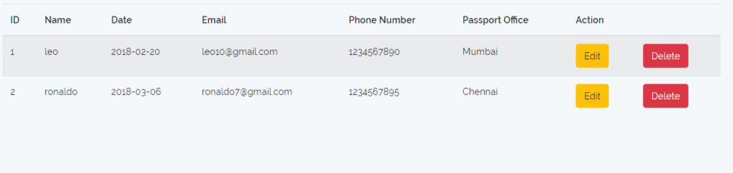](https://appdividend.com/wp-content/uploads/2018/02/Laravel-5.6-Example-Tutorial.png)

**Step 8: Build an edit view for updating the Information.**

Our step will be to join the edit function in **PassportController.php**file and set the following code in it.

*//PassportController.php*

*/\*\**

*\* Show the form for editing the specified resource.*

*\**

*\* @param int $id*

*\* @return \Illuminate\Http\Response*

*\*/*

public function edit($id)

{

$passport = \App\Passport::find($id);

return view('edit',compact('passport','id'));

}

Now, make an **edit.blade.php**file inside **resources  >>  views**

*<!-- edit.blade.php -->*

<!DOCTYPE html>

<html>

<head>

<meta charset="utf-8">

<title>Laravel 5.6 CRUD Tutorial With Example </title>

<link rel="stylesheet" href="{{asset('css/app.css')}}">

</head>

<body>

<div class="container">

<h2>Edit A Form</h2><br />

<form method="post" action="{{action('PassportController@update', $id)}}">

@csrf

<input name="_method" type="hidden" value="PATCH">

<div class="row">

<div class="col-md-4"></div>

<div class="form-group col-md-4">

<label for="name">Name:</label>

<input type="text" class="form-control" name="name" value="{{$passport->name}}">

</div>

</div>

<div class="row">

<div class="col-md-4"></div>

<div class="form-group col-md-4">

<label for="email">Email</label>

<input type="text" class="form-control" name="email" value="{{$passport->email}}">

</div>

</div>

<div class="row">

<div class="col-md-4"></div>

<div class="form-group col-md-4">

<label for="number">Phone Number:</label>

<input type="text" class="form-control" name="number" value="{{$passport->number}}">

</div>

</div>

<div class="row">

<div class="col-md-4"></div>

<div class="form-group col-md-4" style="margin-left:38px">

<lable>Passport Office</lable>

<select name="office">

<option value="Mumbai" @if($passport->office=="Mumbai") selected @endif>Mumbai</option>

<option value="Chennai" @if($passport->office=="Chennai") selected @endif>Chennai</option>

<option value="Delhi" @if($passport->office=="Delhi") selected @endif>Delhi</option>

<option value="Bangalore" @if($passport->office=="Bangalore") selected @endif>Bangalore</option>

</select>

</div>

</div>

<div class="row">

<div class="col-md-4"></div>

<div class="form-group col-md-4" style="margin-top:60px">

<button type="submit" class="btn btn-success" style="margin-left:38px">Update</button>

</div>

</div>

</form>

</div>

</body>

</html>

Next step would be to code the update function. I have not updated the following fields.

1. Date
2. Image

If you are taking this tutorial, then this is the task for you to complete this. I need you to complete this update module on yourself.

*//PassportCpntroller.php*

*/\*\**

*\* Update the specified resource in storage.*

*\**

*\* @param \Illuminate\Http\Request $request*

*\* @param int $id*

*\* @return \Illuminate\Http\Response*

*\*/*

public function update(Request $request, $id)

{

$passport= \App\Passport::find($id);

$passport->name=$request->get('name');

$passport->email=$request->get('email');

$passport->number=$request->get('number');

$passport->office=$request->get('office');

$passport->save();

return redirect('passports');

}

**Step 9: Remove the Information.**

*//PassportController.php*

*/\*\**

*\* Remove the specified resource from storage.*

*\**

*\* @param int $id*

*\* @return \Illuminate\Http\Response*

*\*/*

public function destroy($id)

{

$passport = \App\Passport::find($id);

$passport->delete();

return redirect('passports')->with('success','Information has been deleted');

}

Finally, Our **Laravel 5.6 CRUD Tutorial**is over. Thanks for taking.